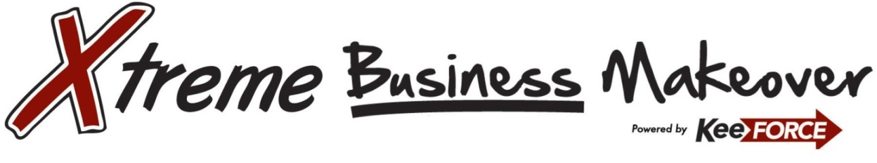
2018 Owensboro Edition Application

What impact would $50,000 in business products and professional services have on your organization?

Xtreme Business Makeover represents a partnership of 17 regional companies dedicated to the success of businesses in the Greater Owensboro Area. The 2018 Xtreme Business Makeover aims to help one lucky organization improve their business operations by taking them from ordinary to extraordinary.

The contest is open to all for-profit businesses who meet the following qualifications: 1.) Organization must be a licensed for-profit business having operated for greater than 2 years as of February 1st, 2018, 2.) Must have a minimum of three employees, 3.) Business must be based in Owensboro Metropolitan Area which includes Daviess, Hancock and McLean Counties in Kentucky. Non-profit organizations, churches and home-based organizations are not eligible. The winner will be selected by an independent panel of judges based on demonstrated need, community involvement, and by the judges’ determination of which organization will benefit most in the long term from the assets being offered as a grand prize. Official Grand Prize Package and Official Rules are available at www.keeforce.com/makeover.

To nominate your business, please complete the following and submit online no later than March 23, 2018.

_____________________________________ __________________________________
Business Name Application Date

_________________________________________________ __________________________________
Street Address Contact Name

__________________________________________________ _______________________________________________
City Contact Title

_________________________________________________ _______________________________________________
State Contact Phone Number

_________________________________________________ _______________________________________________
Zip Code Contact E-Mail Address

Please provide the date your organization was founded; Month / Year:

Number of people employed by your business:

What county is your primary office located:

I have read the official rules associated to participation in this event. By submitting this application, I acknowledge that the organization nominated above has been in operation for at least two consecutive years within the Greater Owensboro Area of Kentucky as of February 1, 2018 and employs a minimum of three people. This is NOT a non-profit organization, a church or a home-based organization. I understand that I may be contacted by a member of the Xtreme Business Makeover team for a qualification interview and will be required to complete a questionnaire as a part of the application process. Should my application be selected as a Top-3 Finalist, I agree to have an organization representative in attendance at the Xtreme Business Makeover Awards reception to be held on or about April 26, 2018.

_________________________________________ _____________________________________
Signature Date

